高二技术选考作业选修6.30
选考班级 | 行政班级 | 姓名
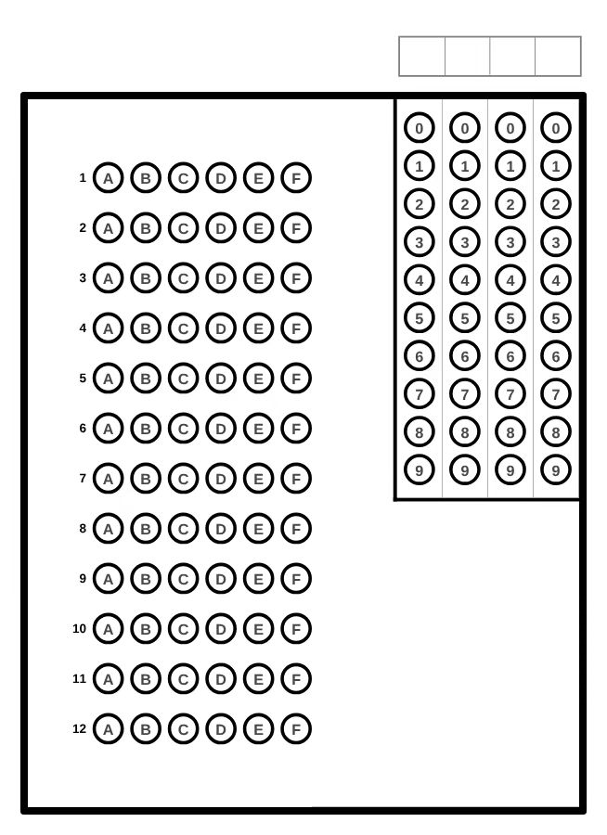
1.①_______________ ②_______________
5._______
①_______________ ②_______________③_______________
6._______
①_______________ ②_______________③_______________
7._______
①_______________ ②_______________③_______________
8._______
①_______________ ②_______________③_______________
9._______
①_______________ ②_______________改_______________

